Project on

Intigrating

GitHub

+

Jenkins

+

Maven

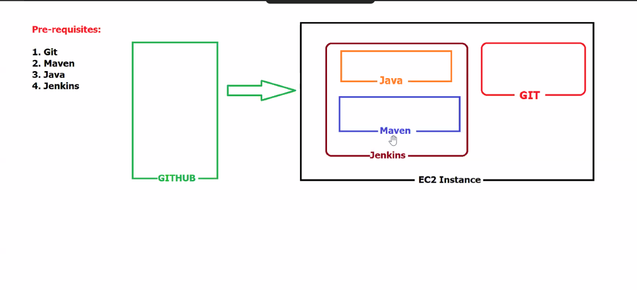

ON EC2 instance

Install

JAVA 1

amazon-linux-extras java-oprnjdk11 -y

This 2 thing is very important

Install Jenkins with

Add Jenkins repo. to our YUM repo:

sudo wget -O /etc/yum.repos.d/jenkins.repo https://pkg.jenkins.io/redhatstable/jenkins.repo

Import a key-file from Jenkins-CI to enable the installation from package:

sudo rpm --import <https://pkg.jenkins.io/redhat-stable/jenkins.io-2023.key>

Install jenkins with:

Yum install jenkins -y

Access it from browser with defualt port 8080:



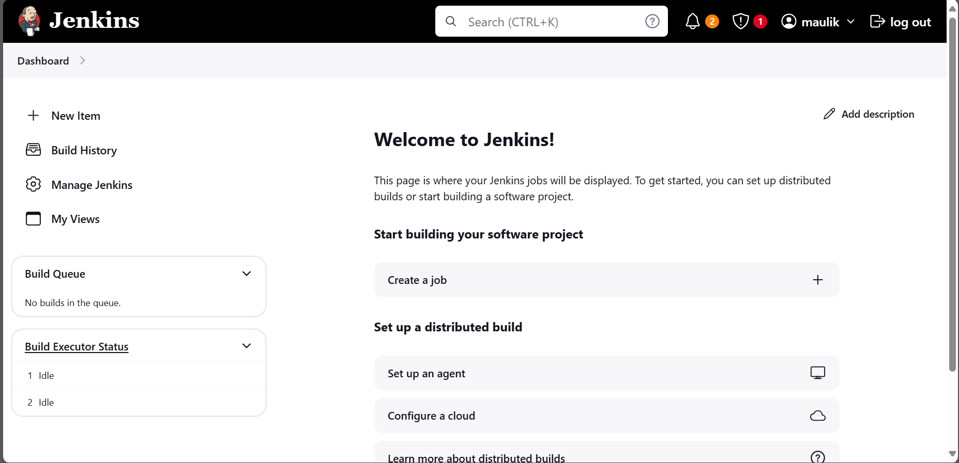

On jerkins we have to configure Maven and java



To do this follow the path

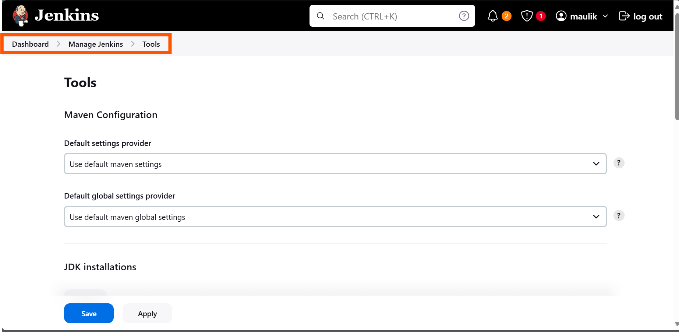

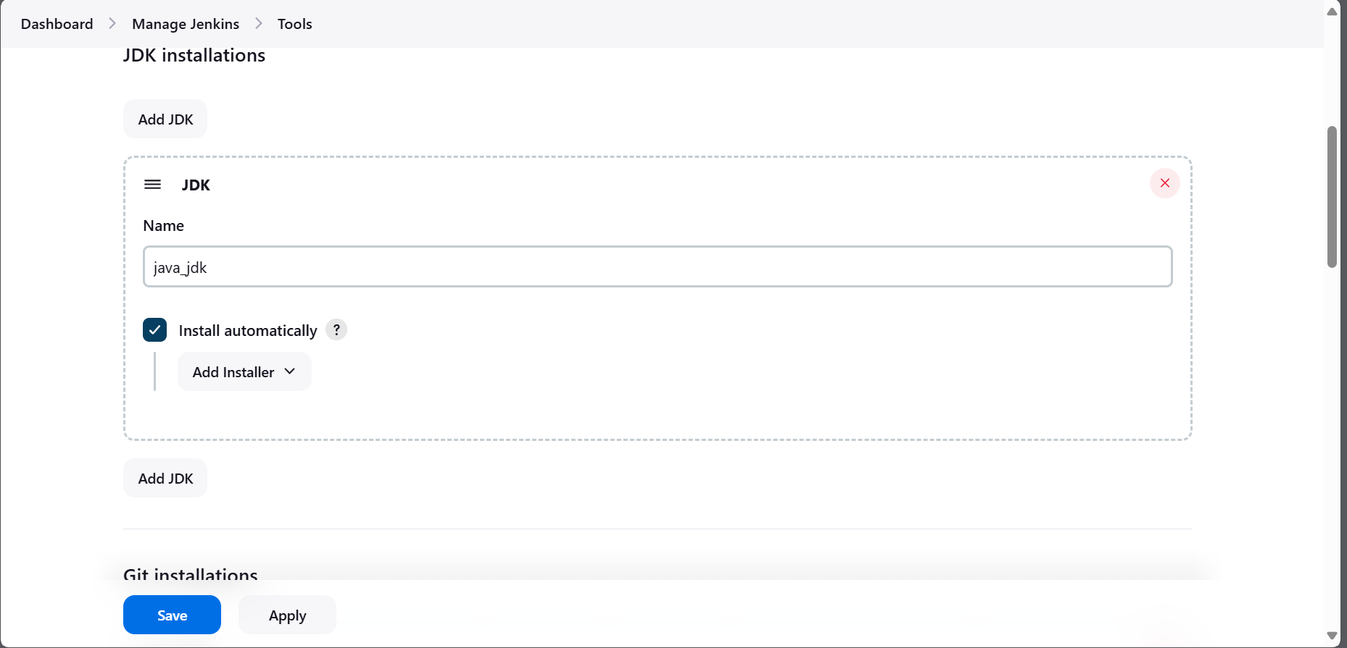

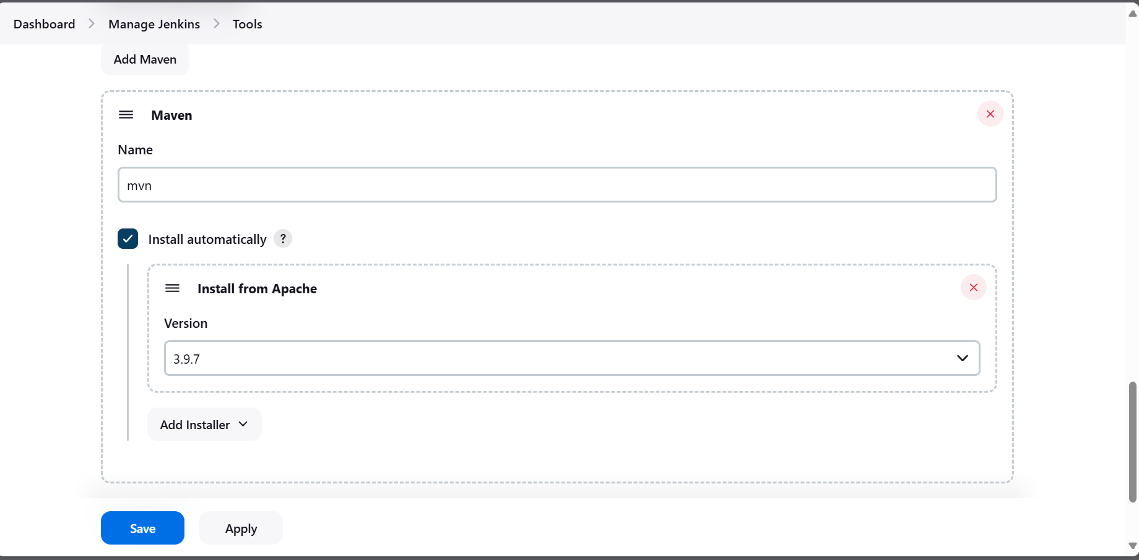

Now we are good to create project one

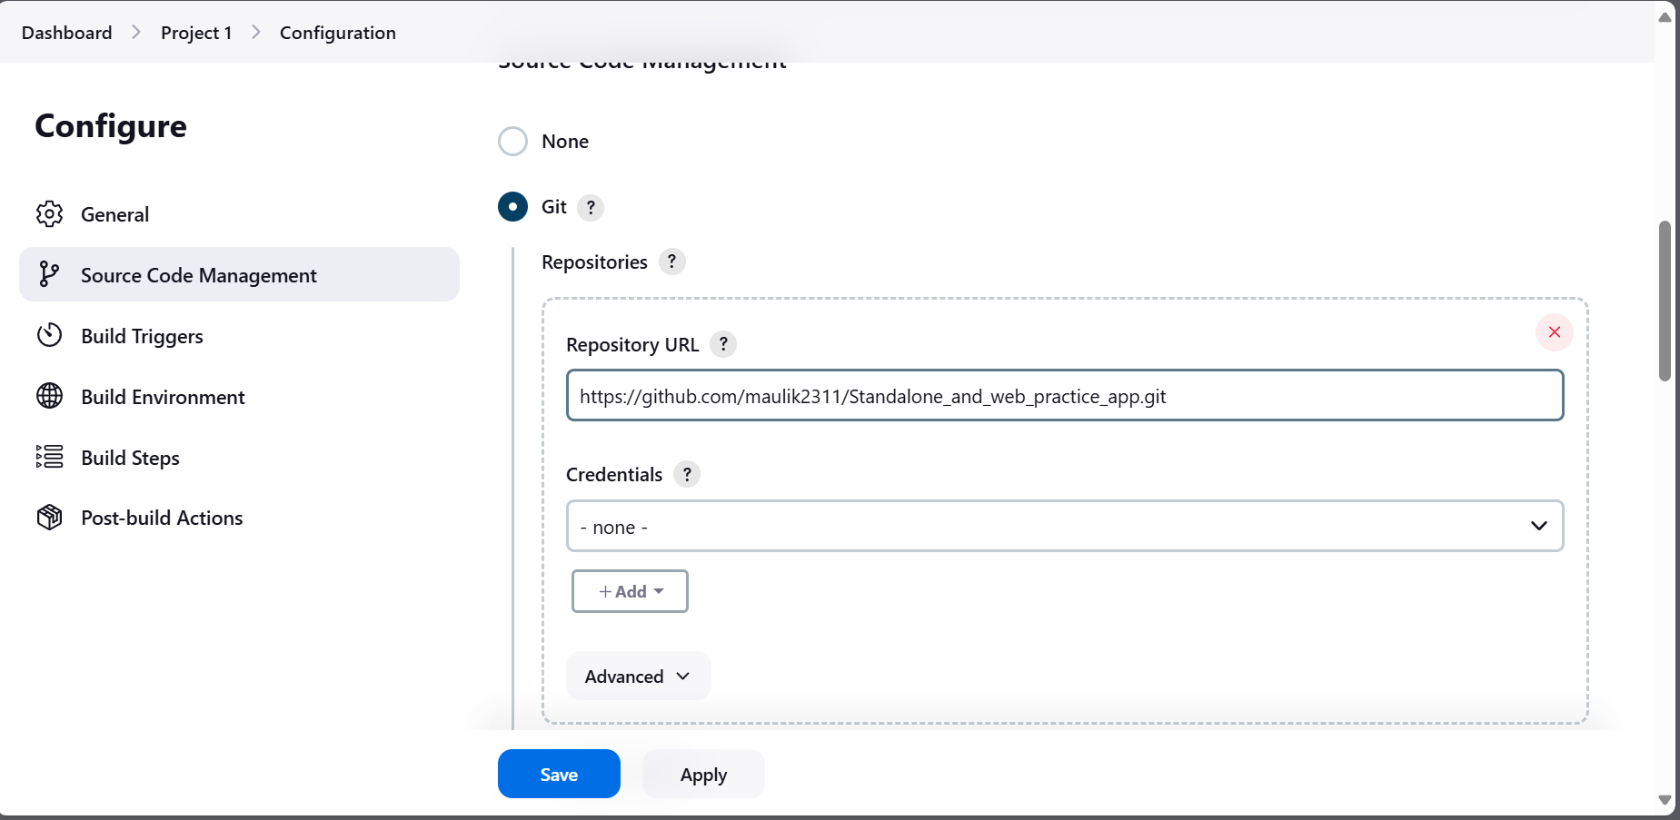

Now we need to comiple and pacakge code with maven, For that only we add maven in jenkins

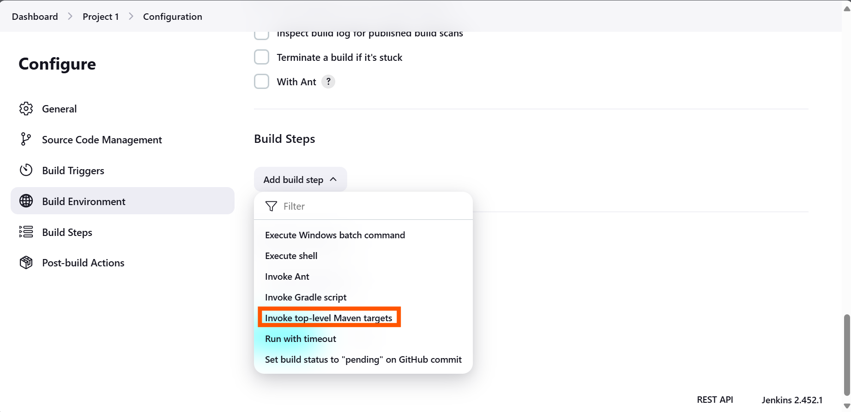

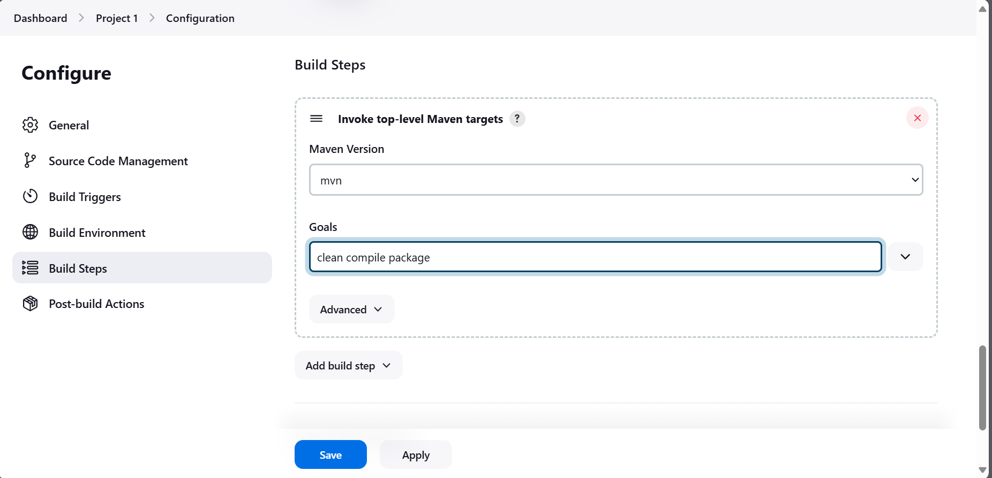

Build fail:::: How to know what is the problem?? --> click on #1 and check consule output that have all information

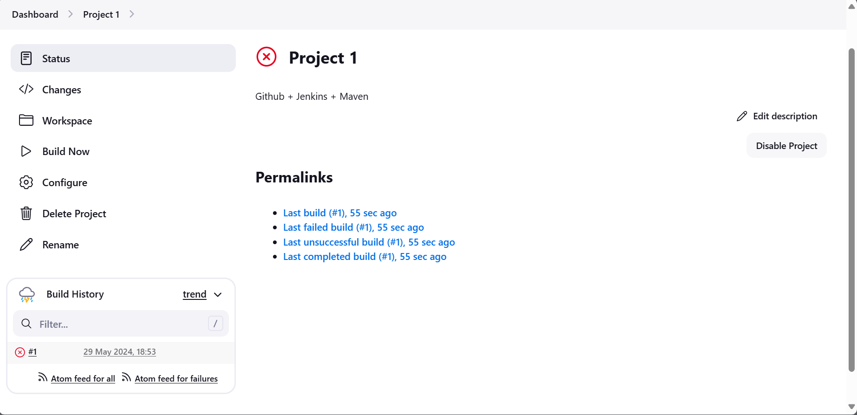

There is no POM file on path

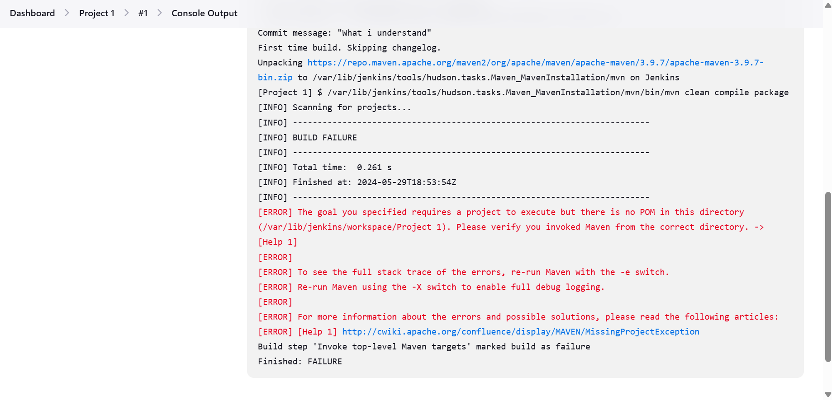

Lets try with proper path.

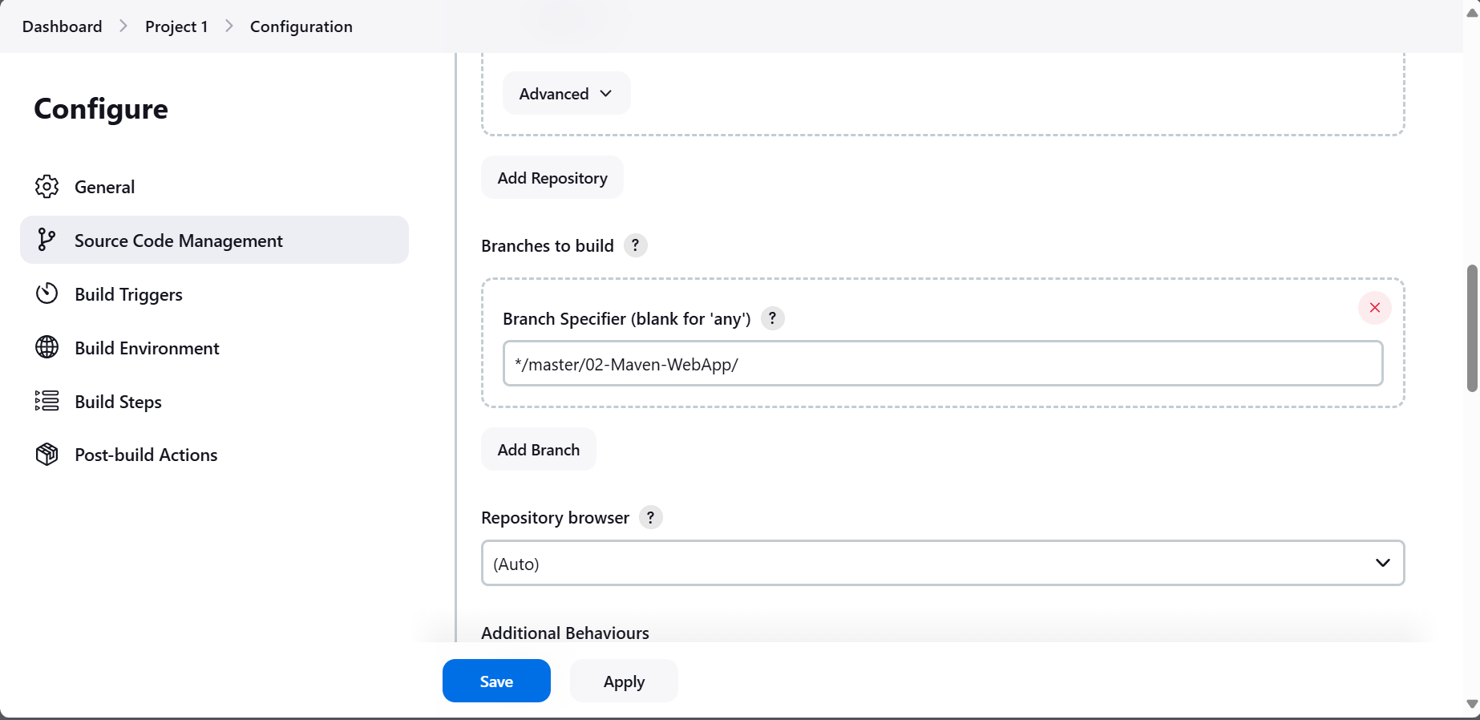

Total number of fail build 3:

Build Fail 1: no pom directory

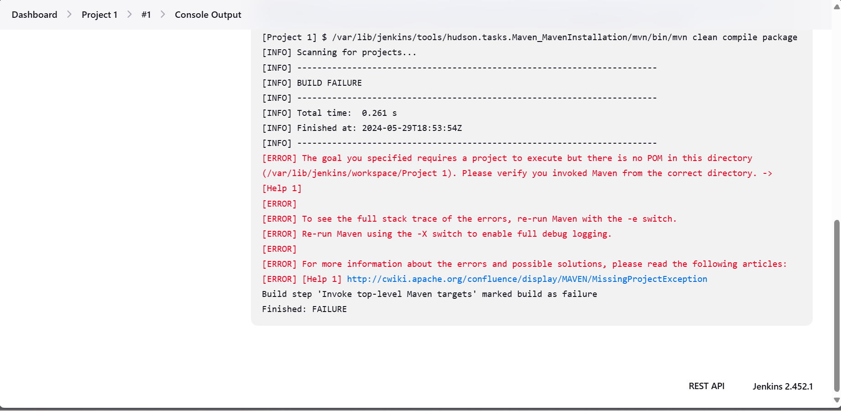

Try to solve

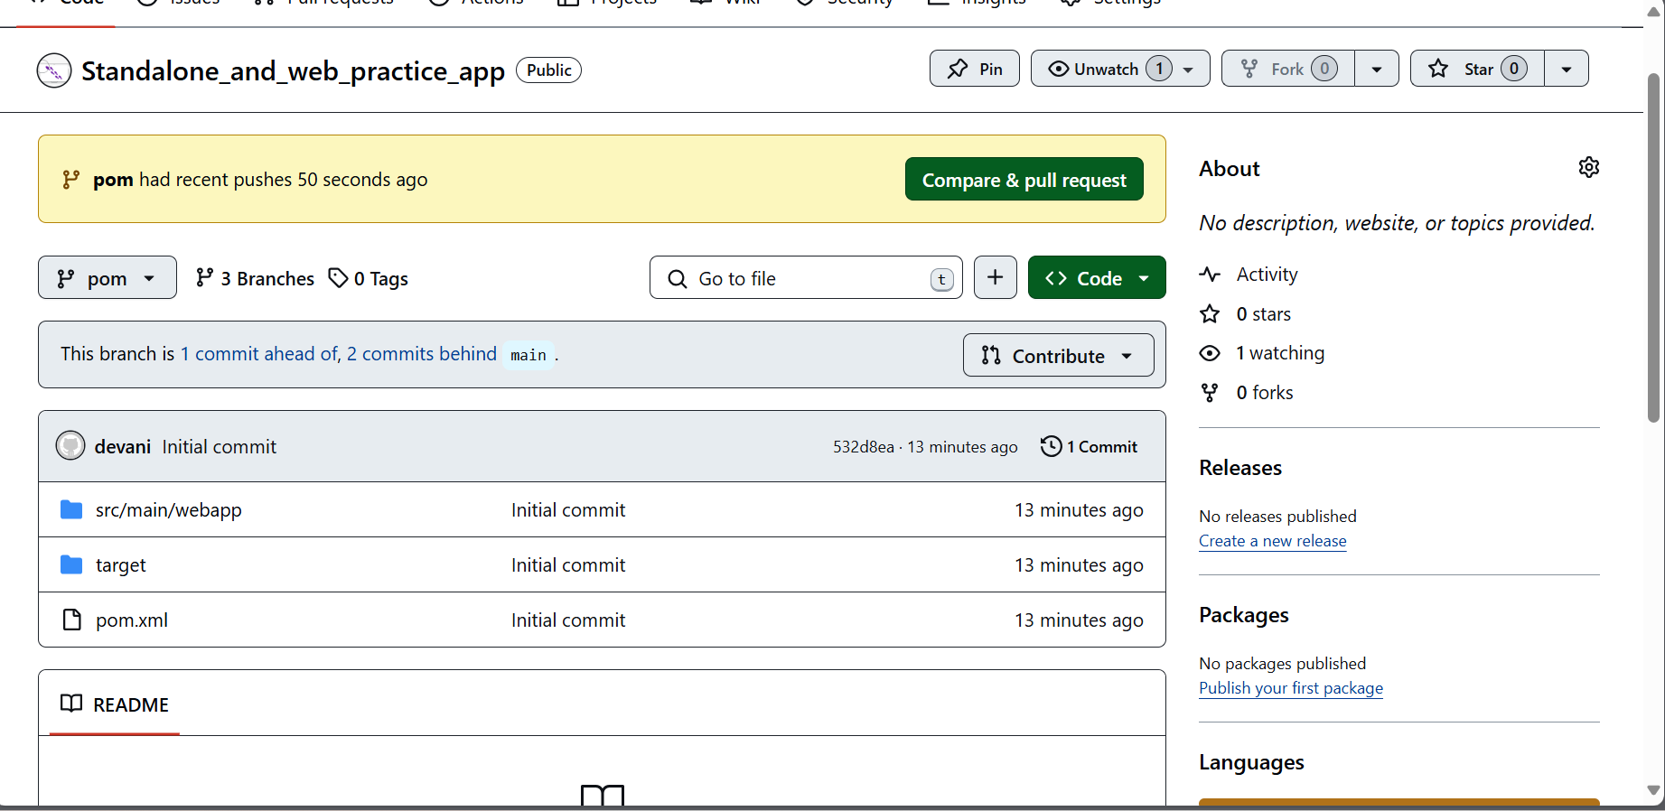

Build Fail2:

Not able to understand what is the problem

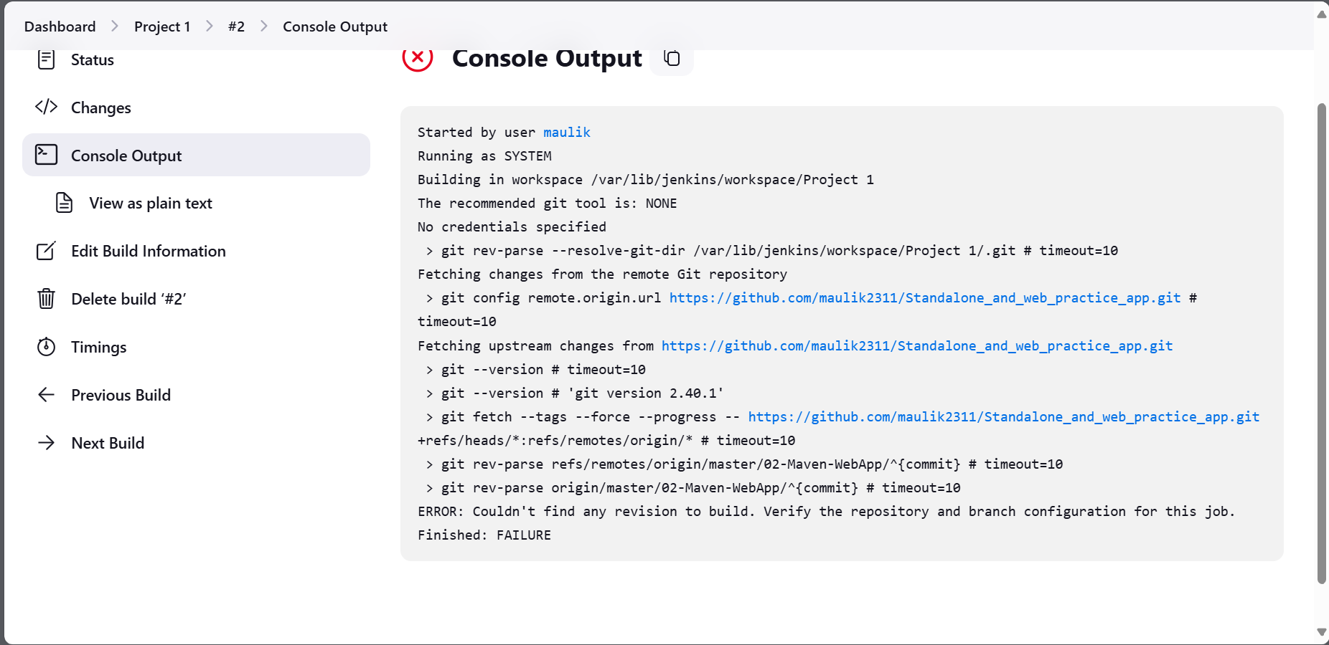

Build Fail #3:

Slowly understand what is the problem

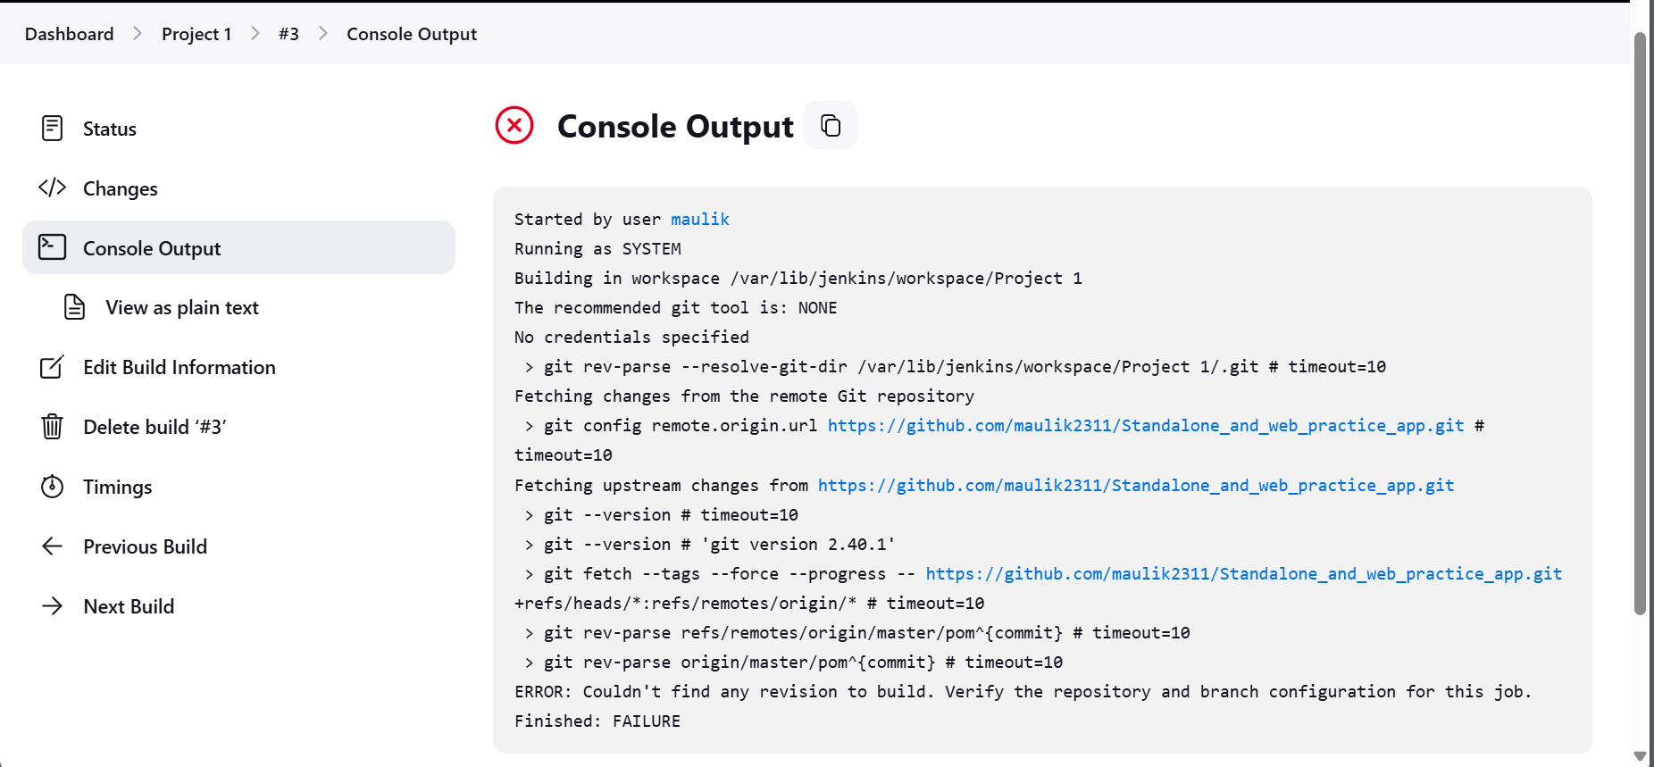

Build #4: Successes

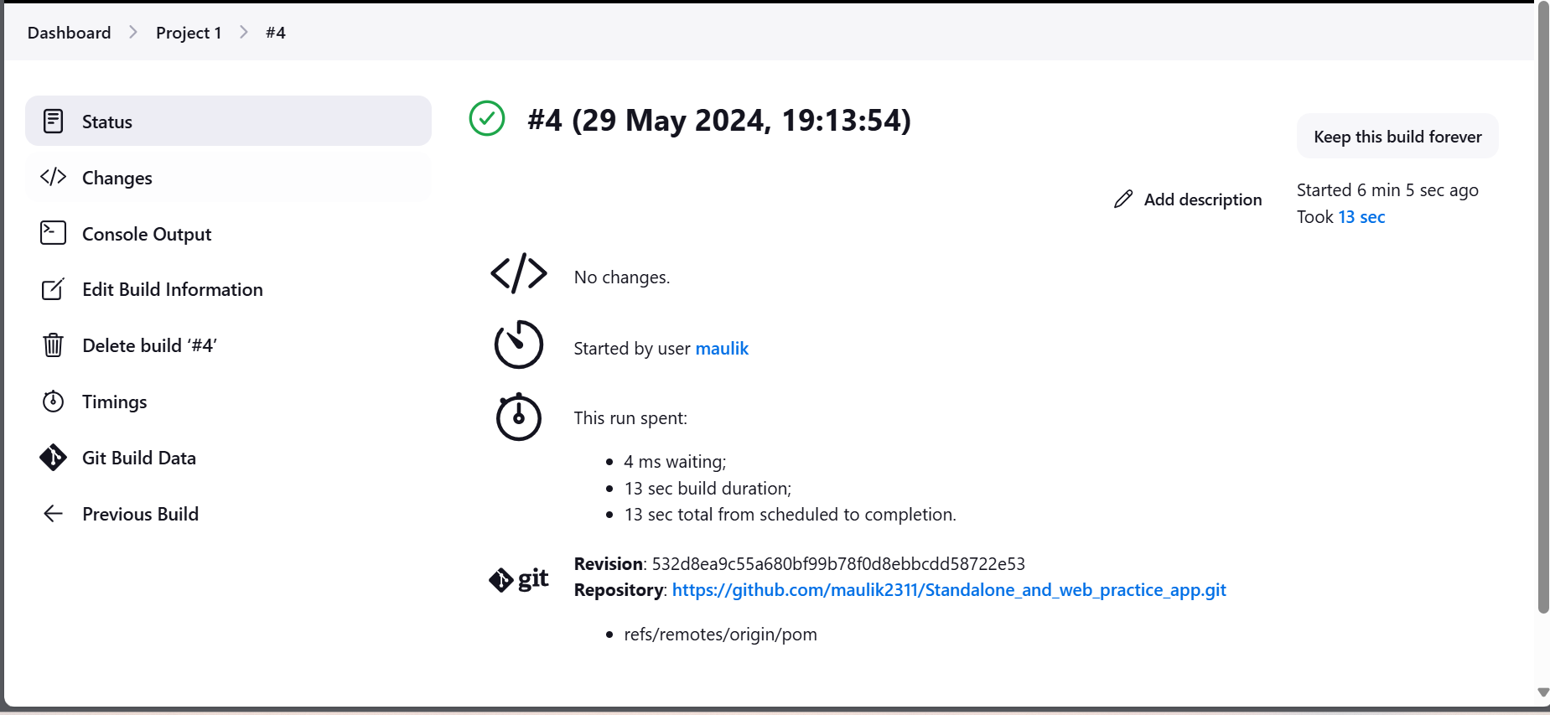

Problem that occur:

Path of repo

